Chatgpt :   
<https://chatgpt.com/share/68221694-cd60-8007-8ab1-8e48ff21978a>

perplexity.ai:   
<https://www.perplexity.ai/search/create-a-perfect-script-like-a-z6Mn5R.nTZa101fTiu9dQA>

Ai.invideo.io:   
https://ai.invideo.io/

Prompt 1:  
Create a video for TikTok using exactly this script:

Theme: Humor, Informative, Dramatic, Attractive

Approach: Engaging parody of music talent shows and tech ads, highlighting product features through funny, memorable scenes.

[0:00–0:05]

Visual:

Parody intro-dramatic “talent show” opening, spotlights sweep a bathroom door. Text: “A Star is About to Be Born… in the Shower!”

Audio:

Epic announcer voice:

“Tonight, one voice will rise… from behind the shower curtain!”

[0:06–0:12]

Visual:

Cut to Sam, a shy kid, nervously clutching a shampoo bottle “mic” in his room, lip-syncing to a pop song poster.

Audio:

Narrator (whispery, mock-serious):

“Meet Sam. He dreams big, but sings small. Public? Never. Private? Maybe…”

[0:13–0:18]

Visual:

Mom peeks in, grins, and presents the AquaKaraoke Shower System box with a game show flourish. Parody “QVC” voiceover.

Audio:

“Introducing the AquaKaraoke Shower System! The only shower head that lets you sing like nobody’s watching-because nobody is!”

[0:19–0:30]

Visual:

Montage: Mom installs the shower head, using a comically oversized wrench. Rubber duck “judges” watch, holding up “?” scorecards.

Sam steps in. He presses a button-the built-in speaker blasts a jingle, startling him and making the ducks “jump.”

He sings off-key; the echo effect makes it sound like a sci-fi robot. LED lights flash red in mock alarm, then green when he improves.

He tries animal impressions (meowing, quacking), makes silly faces, and the portable shower head swivels to “applaud.”

Audio:

Narrator (parody tech ad):

“Crystal-clear sound, splash-proof design, and dazzling LED feedback. It’s not just a shower-it’s a show!”

[0:31–0:43]

Visual:

Parody talent show: Sam imagines the bathroom as a concert arena. Rubber duckies hold up “10” scorecards, bubbles float like confetti, and the LED lights sync to his singing.

He tries different genres-opera with dramatic gestures, rock with air guitar (loofah), pop with backup echoes.

Audio:

Narrator:

“Easy to install, totally portable, and always ready for an encore-AquaKaraoke turns every wash into a wow!”

[0:44–0:54]

Visual:

Sam nails a high note. The shower head “bows,” LED lights go wild, and the ducks erupt in applause. Mom listens outside, beaming.

Quick cut: Sam on stage at the school talent show, echoing his shower performance. The crowd cheers.

Audio:

Announcer (parody):

“From bathroom ballads to real applause-AquaKaraoke brings out the star in everyone!”

[0:55–1:00]

Visual:

Product shot: AquaKaraoke Shower System, sparkling with animated musical notes and water droplets. Sam winks at the camera, holding the shower head like a trophy. On-screen text: “Sing. Shine. Repeat. Get yours today!” QR code for special offer.

Audio:

Upbeat jingle (parody pop hit):

“AquaKaraoke-where every shower’s a standing ovation!”

End with logo and slogan:

AquaKaraoke Shower System: Unleash Your Inner Superstar-One Shower at a Time!

Notes:

Parody elements (talent show, tech ad, QVC) make features funny and memorable.

Humorous initial attempts (animal sounds, silly faces, echo mishaps) show relatability and product interactivity.

Product features (speaker, echo, LED, portability) are woven into the action, not just described.

Dramatic transformation and call to action wrap up the story with energy and clarity.

Settings:

Use only stock media

Add any subtitle

Use any voice with a clear American voice for the Narrator

Prompt2:   
  
create a perfect script like a director for an Advertisement whic both informative and entertaining, with a duration of 60 seconds

theme: humor , informative , dramatic , attractive

product : AquaKaraoke Shower System

Product deatils:

Transform your daily shower routine into a musical experience with this portable shower head, allowing you to sing along to your favorite tunes while enjoying a refreshing wash.

Plot details : little introvert kid love to sing but is shy to sigh in public so his mother affectionally buys and get this installed in bathroom , initially he sings badly later he turns into singer

points for consideration:

1. add some humorous ways to show the kid's initial singing attempts

2.incorporate the product's features in a funny and engaging manner

3. use parody to make the product's features more engaging  
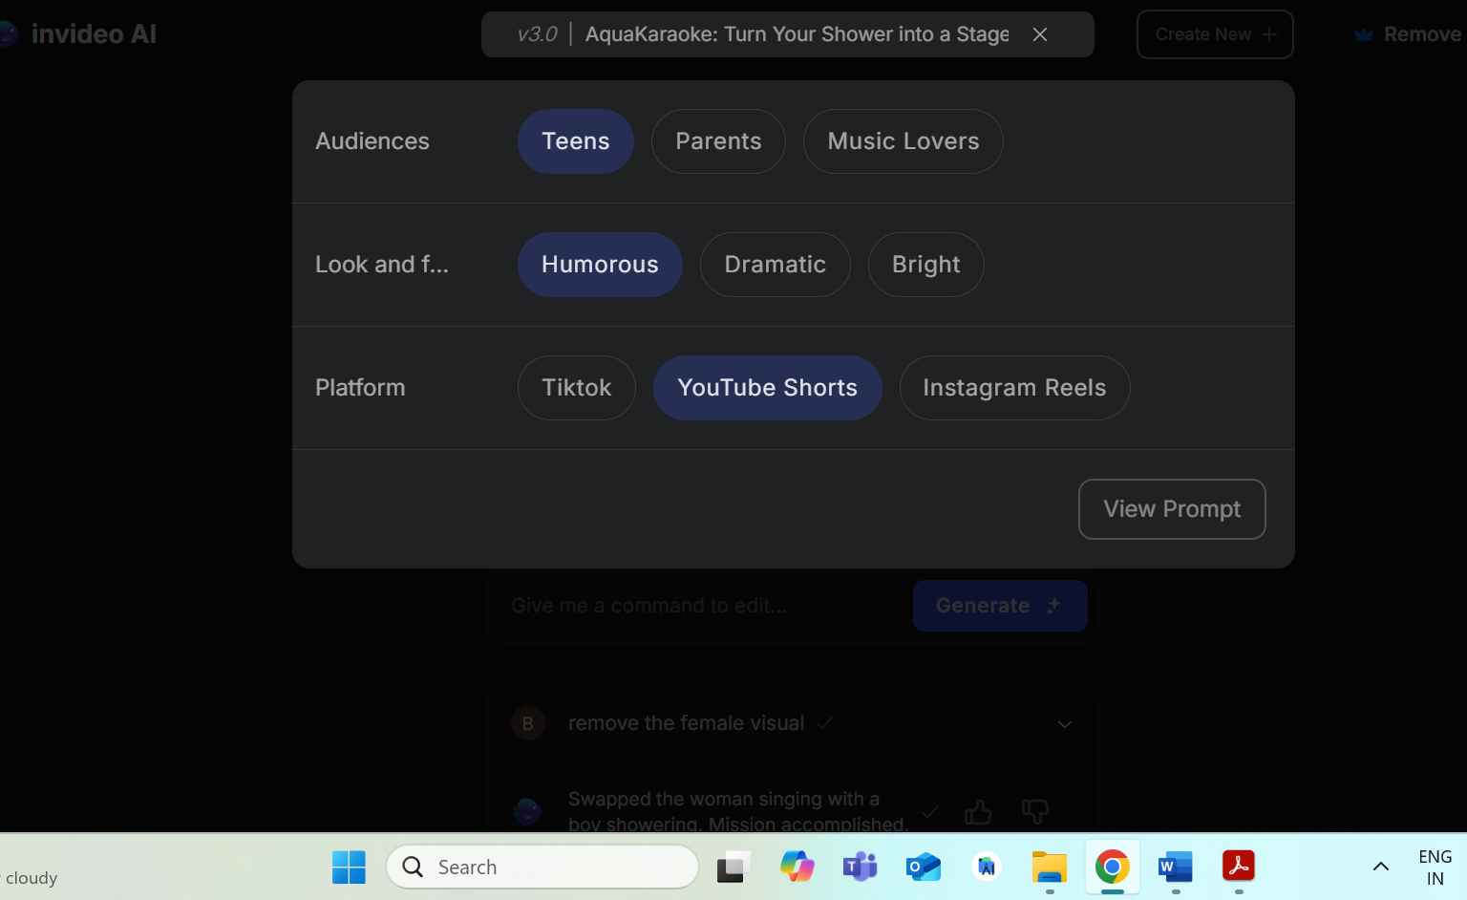

prompt 2:   
remove female visuals  
